No.11-NT(07)/2012 14th August, 2012

CASULTY CIRCULAR NO. 04 of 2012

Sub: Collision between two Motor Tankers.

1. What happened ?

A Motor Tanker ‘X’, in ballast passage, while transiting in the deep water route off Gulf of Kutch, collided with another tanker ‘Y’ on her port side. The collision caused localized indents/buckling of plating/structures in way of mid ship section. There were no breach of ship’s hull. No person was injured and no oil pollution occurred. Both vessels, after the collision resumed their passage.

2. How it happened ?
2.1 “X” had sailed out from Haldia on 16.01.12 and was approaching RJMT, Sikka, in ballast, for loading product cargo. “Y” had sailed from Logos, Nigeria on 03.11.11 bound for Alang, India, for demolition. The collision occurred on 23.01.12 at approximately 1958 local time. At the time of collision, the bridge watch on “X” was manned by Chief Officer and one cadet. The visibility was very good and weather was slight sea with low swell. All the navigational equipments were operational and navigational charts were updated to the latest notice to mariner. “X” was navigating on chart No. 682, off Mithapur Buoy, on a chartered course of 023 degrees (T) while “Y” was on course 067 deg. (T), towards Bedi anchorage.

Actions by both vessels preceding the collision:
2.2 At 1905 hours, “X” was on a course of 342 (T) and at speed of 13.1 knots while sailing in the deepwater route off Dwarka light house. The radar picture showed few fishing targets on port and starboard bow, passing clear of the vessel. “Y” was seen on the radar, very fine on the starboard bow, on an easterly course.

…….2/-

-: 2 :-
RADAR SCREEN AT 1905
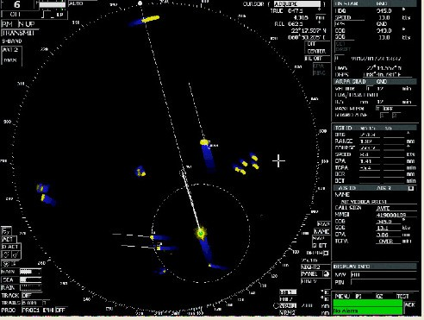
TARGET ‘ Y’

‘X’

2.3 2.5 At 1917 hrs, Motor Tanker “Y” had slightly ‘opened’ to about 1-2 point on the starboard bow, distance 5 miles and as per trails, on ENE course. At this time, “X” altered her course, as per her passage plan, to 023 degrees (T).

RADAR SCREEN AT 1917
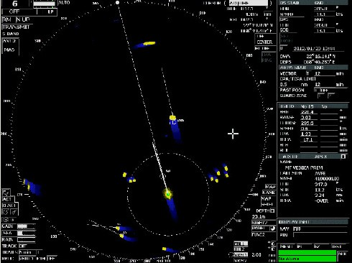

TARGET ’Y’

‘X’

…..3/-
-: 3 :-

2.4 At 1925 hrs, another vessel “St. Peters” was seen to be passing clear with CPA of 9 cables, on course 203 deg. (T) and speed of 13.4 kts. At 1927 hrs, ‘St Peters’ had altered to 214 deg. (T) and speed 12.5 kts with CPA reduced to 5.4 cables and TCPA of 6.4 mins. Around 1928 hours, “St. Peters” had further altered her course to starboard to 221 deg. (T), further reducing the CPA to 4.1 cables. At 1930 hrs, motor tanker ‘X’ and “St. Peters” altered their respective courses to starboard to avoid imminent collision. “St. Peters” crossed the bows of ‘X’ and passed on the port side, at 2.5 cables. Thereafter, at about 1936 hrs, ‘X’ altered her course back to 023 deg. (T). Master was not notified of this close quarter situation.

2.5 At 1936 hrs, ‘Y’ was seen at distance of 3 nm, maintain same course and speed. No fishing boats were seen ahead. At 1947 hours, “Y” was acquired at a range of about 2 nautical miles at 1 point on the port side of ’X’. This target was being depicted (on the radar of “X”), a red colored vector and visual and audio alarm of CPA were seen to have been activated, to indicate that CPA of the target was 0.5 miles or less and TCPA was 12 minutes or less.

RADAR SCREEN AT 1933

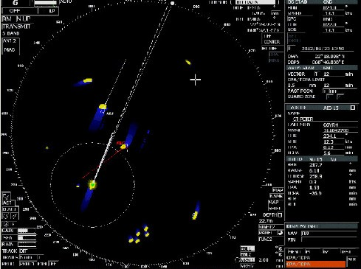

TARGET ‘Y’

‘ST. PETERS’

‘X’

……..4/-

-: 4 :-
RADAR SCREEN AT 1948
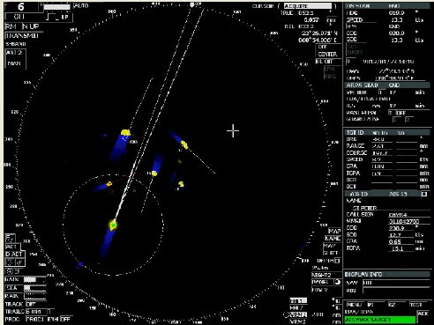

TARGET’Y’

‘X’

2.6 At 1950 hours, “Y”, though acquired on the radar, was not verified by the bridge watch of the Motor Tanker “X”. At this time, “Y” was steering a course of 069 degrees (T) and at a speed of about 6.2 knots. This was observed to be on a collision course.

2.7 Between 1951 hrs to 1955 hours, no actions were taken, either by “X” or “Y”. At 1954, ‘X’ was acquired indicating bearing 353.9 deg, range 0.75 nm, course 069 deg. (T), speed 6.2 kts, CPA 0.01 nm and TCPA 4.5 mins.

2.8 At 1955 hrs, another vessel on a reciprocal course, on starboard side, informed “X”, on VHF that the navigation lights of “X” were not visible. This was verified and the navigation lights thereafter were switched on by “X”.

RADAR SCREEN AT 1955
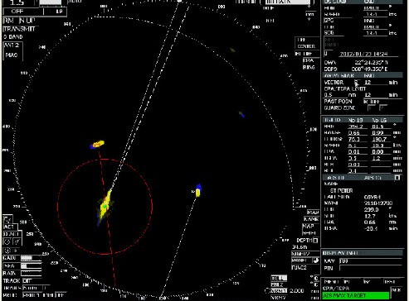

…..5/-
-: 5 :-

RADAR SCREEN AT 1958
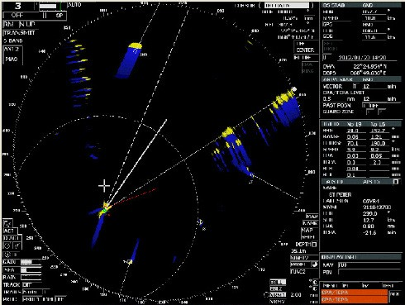

2.9 At 1955 hrs, “Y” altered course to starboard to 082 degrees (T). Thereafter, between 1956 hrs to 1957 hrs, both, “Y” and “X”, altered their courses to port. At 1957 hours, “X” started altering to starboard and then subsequent alterations were ordered to “hard starboard’ and to port.

2.10 At about 1958 hrs, “Y” made contact with “X” in way of water ballast tank and HFO tank on the port side.

DAMAGE TO PORT SIDE HULL OF ‘X’
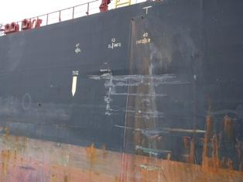

…..6/-
-: 6 :-
DAMAGE TO INNER HULL
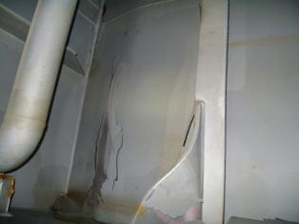

3. Why it happened ?
3.1 Lack of effective monitoring and poor situational awareness of traffic by ‘X’ was the most proximate cause of the collision. Contributory factors included inadequate manning of the bridge watch, navigational lights not being switched ‘on’ and also apparently poor training and competence in keeping a proper bridge watch procedures.

3.2 Though at 1905 hrs, there was no risk of collision between ‘X’ and ‘Y’, the situation changed after ‘X’ altered course, as per her passage plan, to 023 deg (T) at about 1917. At this time, ‘X’ bore about 100-115 deg from ‘Y’ and finally converged into ‘Y’ due to her larger speed. Therefore, technically, the developing situation could not be said to be an ‘overtaking’ situation.

3.3 Since the navigation lights of ‘X’ were switched ‘on’, just a couple of minutes before the collision, ‘Y’ could not have visually seen ‘X’ until the collision was imminent. On ‘X’, the green side light of ‘Y’ was visible at all times and because of her greater speed, it should have been evident to ‘X’ that she was converging onto ‘Y’.
Rule 13 (C) states that when a vessel is in any doubt as whether she is overtaking another or not, she shall assume that this is the case and act accordingly.
Therefore, a proper assessment of the developing situation and correct appreciation of Rule 13 (C) should have alerted ‘X’ to take avoiding action as per overtaking vessel or in any case under Rule 2.
……7/-

-: 7 :-

3.4 For ‘Y’, the situation was that of vessel not in sight of another vessel, except probably on radar (details not available). However, Rule 19 of Colreg would not be applicable since ‘Y’ was in sight of ‘X’ and visibility was good. Watch keeping on ‘Y’ which was on her last voyage was ineffective. An alert bridge watch on ‘Y’ would have avoided the close quarter situation by taking action either as a ‘give-way’ vessel (for crossing situation) or as per Rule 2, since there was a doubt as to whether ‘X’ was overtaking or crossing.

3.5 Inadequate bridge manning at the time when considerable fishing traffic was being encountered. There was no helmsman on bridge and also the Master was not called even after having narrowly avoided a collision with a passing vessel.

4. Lessons learnt
4.1 Use of ‘trial maneuver’ function by ‘X’ prior to alteration to 023 deg (T) would have would have alerted for a possible close quarter situation with ‘Y’.

4.2 On ‘off centre’ mode, there is a distinct advantage to ‘see’ more ships ahead (in cases when the centre is moved back). However, watch keeping should also be aware that there is relatively less time to react for ‘overtaking’ vessels coming up from the astern. Therefore, it is important not to navigate on the off centre mode at all the time.

4.3 Monitoring of AIS display on ‘X’ would have indicated the destination of ‘Y’ to be Alang and this could have also alerted ‘X’ for the voyage of ‘Y’ to the scrap yard and hence the possibility of non-operational radar and lax watch-keeping.

4.4 Passage plan should be clearly marked for time and location when a helmsman would be needed while encountering traffic, particularly fishing traffic near the coast.

4.5 Watch-keeper should not hesitate to call Master when a close quarter situation is developing.

4.6 Multi tasking by watch-keeper should be reduced by adequate bridge manning.

4.7 Verifying that navigation lights are ‘on’, should be a mandated task prior to taking over the watch.

Capt. Harish Khatri
Dy. Director General of Shipping (Tech)

